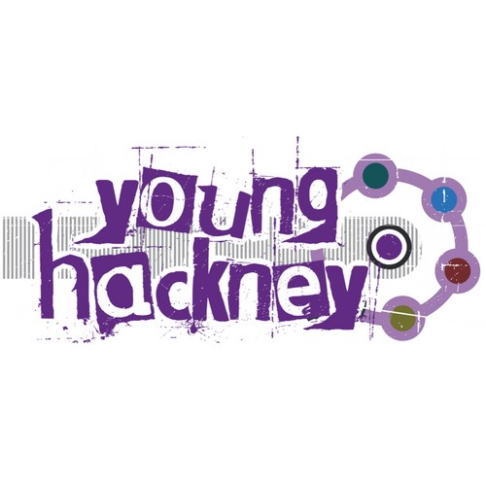
Youth Opportunity Fund 2017

Terms and Conditions

Terms and Conditions

General

- Applications to Hackney YOF must be for projects/activities that benefit young people living or attending school in Hackney, between the ages of 8 and 19 years, and up to 25 years if they have a disability or learning difficulty.

- Grants are available for up to £3,500. You can request any amount between £500 and £3,500.

- Young people must be involved in designing and planning the project and in completing the application form.

- Group must be made up of at least three young people. Contact details for three young people must be provided on the application form.

- You must submit a completed application form and risk assessment for your application to be considered.

- The YOF panel will assess all applications to see if they are eligible for funding. Eligible projects will be invited to interview.

- The project group and adult sponsor will be invited for a short interview with the YOF Panel members, so they can ask you about the project.

- You must not start your project/activity until you receive a confirmation letter from us telling you your application has been successful.

- Applications that involve or help groups of vulnerable young people will be given additional marks in the decision-making process.

Policies, documents and payments

- Grants will be paid in two instalments: 75% will be paid before the start of the project and 25% will be paid at the end of the project on condition that the project has been completed and the required evidence (including receipts) has been provided.

- Applications must have a support organisation, which must be a constituted group with its own bank account. This may be an organisation such as a school or youth club but could also be a voluntary or community sector organisation working with young people. Unfortunately, we cannot accept applications from individuals working without the support of an organisation.

- In some circumstances, for example if your organisation has not been funded by Hackney YOF in the past, we may ask for copies of your audited accounts

- The organisation will be responsible for all financial evidence of spend. The named adult contact must be a responsible employee of the organisation.

- The supporting organisation will be accountable for the returns of financial data, monitoring data and risk assessments.

- All organisations must have an equal opportunities policy, health and safety policy, and a child protection policy. These documents must be supplied when requested. Your offer of funding will be conditional on receipt of these documents.

- The supporting organisation is responsible for safeguarding during the project. The adult from the supporting organisation working with young people to deliver the project must have a DBS check and relevant qualifications. Staff and volunteers who will be working unsupervised with young people will also require a DBS check. You will be asked to supply evidence of these documents. Your offer of funding will be conditional on receipt of these documents.

Equal Opportunities

- Applications must show how you intend to put Equal Opportunities policies into practice.

Health and safety

- The supporting organisation must have at least one staff member with an up-to-date First Aid certificate.

Risk assessment

- Risk assessments must be carried out on each separate project/activity and the premises in which it will be taking place. Ordinarily all risk assessments must be submitted at the time of submitting your application. But if your project is a residential you must ensure you have carried out your risk assessment in advance of your trip, and this must be submitted to the Youth Offer Co-ordinator at least 4 weeks in advance of your trip.

Project/activity monitoring

- Your project must be completed within one financial year, e.g. 1 May 2017 to 31 April 2018. Your award and spend cannot be carried forward into the next financial year.

- Projects will be asked to keep membership and attendance records of young people involved in and benefiting from the project along with their contact details. This should be submitted at the end of the project.

- As part of monitoring, the panel of young people may visit your project to monitor your activity. If this happens, we will let you know in advance. Please ensure opening times, dates, venues as well as any changes are reported to the YOF team so they can plan visits.

- At the end of your project, you are required to submit an end-of-project report, together with any photographic images, or audio or visual material (CDs, DVDs) you have produced during the project. The group who delivered the project will also be asked to attend an evaluation workshop where they will give a presentation on their project.

- You are required to provide evidence of your spend by producing receipts, supplier invoices, online payment confirmation, etc. Hackney YOF will only fund project spend, we ask that you do not claim for money that is not associated with the project.

Breach or failure

- Any organisation that has not met the requirement to provide monitoring information will not be eligible to apply for additional funding whilst their monitoring information is outstanding.

- No second grant will be issued to organisations (projects) that have failed to deliver and/or have not provided evidence of participants and impact of the project.

- It is the responsibility of the supporting organisation to supply the correct documentation. If you do not supply receipts or invoices LB Hackney reserves the right to deduct any undocumented expenditure from the final grant.

Third party

- Where you are asking a third party organisation to deliver your project, your application must still be endorsed by the supporting organisation. This must be evident on your application or in a covering letter.

- Your organisation must agree to allow access for London Borough of Hackney to audit the funds and activities if required.

